**Rental Proposal – Exclusive Accommodation for COP30 in Belém (Pará)**

Dear,

We are offering a spacious house with 4 bedrooms in a gated community for rent during the COP30 period, in Belém (PA), ideal for delegations, organizations or teams looking for comfort, security and a strategic location.

Offer Details:

* Rental period: 15 days, during COP30
* Location: Gated community with 24-hour security, just a 5 minutes walk from the COP 30 event venue (BLUE ZONE and GREEN ZONE)
* Services included: Cleaning services
* Air conditioning in all bedrooms and living room.
* Fully equipped kitchen
* High-speed Wi-Fi
* 02 parking spaces

Casa 184 Condomínio Bancrévea

Neighborhood: Souza

City: Belém (Pará)

Bedrooms: 04 (Availability for 10 peoples)

Rental Value: U$ 35.000,00 (Thirty-five thousand dollars)

Period: 15 daily (to be defined in November 2025)

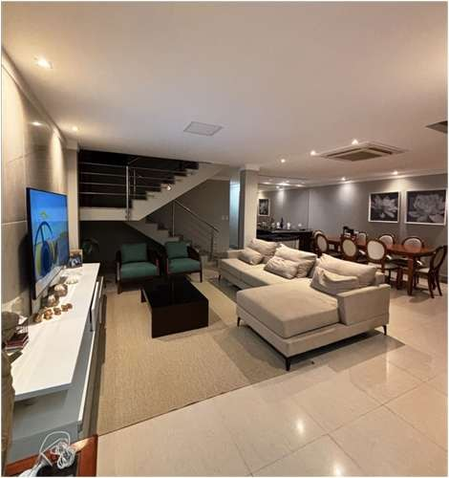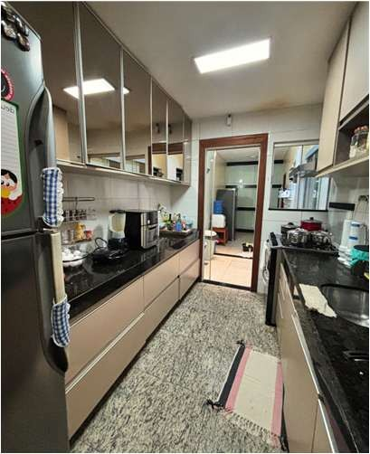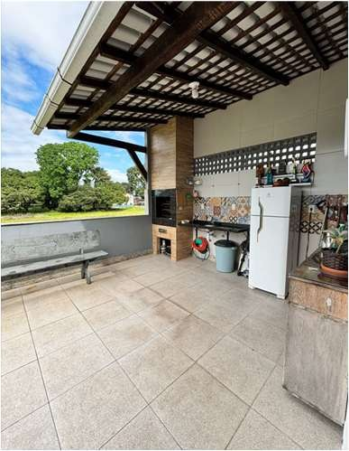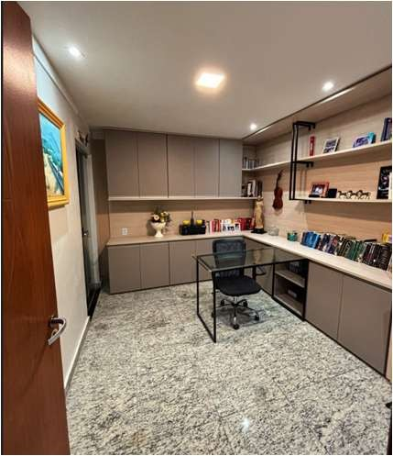

The house is very comfortable, spacious and ideal for those who want to stay in a practical and safe environment, in one of the most privileged locations in the city during the COP 30 conference. In addition to excellent accommodation.

I am available to provide images of the properties, schedule visits (in person or online) and clarify any questions.

Yours sincerely,

# MANOEL RAMOS PINTO JÚNIOR

Contact: +55 91 988573700

E-mail: manoel.especialista@gmail.com